Dylan Schulzª
Fabian Wenger^{b}, Bastien Penninckx^{b}, Xin Wen^{b}, Sankar Sasidharan^{b}, Anders Palmqvistª, Anna Martinelliª
ªDepartment of Chemistry and Chemical Engineering, Chalmers University of Technology, 412 96 Gothenburg, SE
^{b}Smoltek Hydrogen AB, 411 18 Gothenburg, SE
dylans@chalmers.se

Using Raman Mapping with FIB and SEM to characterize complex 3D structures in PEM electrolyzer materials

Proton exchange membrane (PEM) electrolyzers are part of a cohort of technologies that promise to enable a green and scalable energy system based upon hydrogen. Central to their operation is the membrane electrode assembly (MEA), consisting of two electrodes and a membrane. Here there is a large materials science challenge as the MEA needs to provide good electrical contact, catalyst access, mass transport processes in aqueous and gaseous phase, and high durability in a harsh electrochemical environment [2]. To develop such materials, it is vital to understand both their morphological and chemical properties, however this is often challenging due to the 3-dimensional differences in the materials and the difficulty in accessing different sections of a material with most instruments. The Pt-covered carbon nanofiber anodes produced by Smoltek AB exemplify this, as there are major differences in eg. the void fraction, distribution of supporting ionomer and distance to the membrane at different parts of the material. By using a focused ion beam (FIB) to make a diagonal section into the material, the depth of the material can be explored using SEM to track morphology and Raman spectroscopy to track characteristic chemical bonds, such as the Iridium oxide catalyst [3].

References

- Ruei-San Chen et. Al., Nanotechnology, 17 (2006) R82
- Venkata Yarlagadda et. Al., ACS Energy Lett., 3 (2018) 618-621
- Zoran Pavlovic et. Al., Chem. Commun., 53 (2017) 12414-12417

Figures

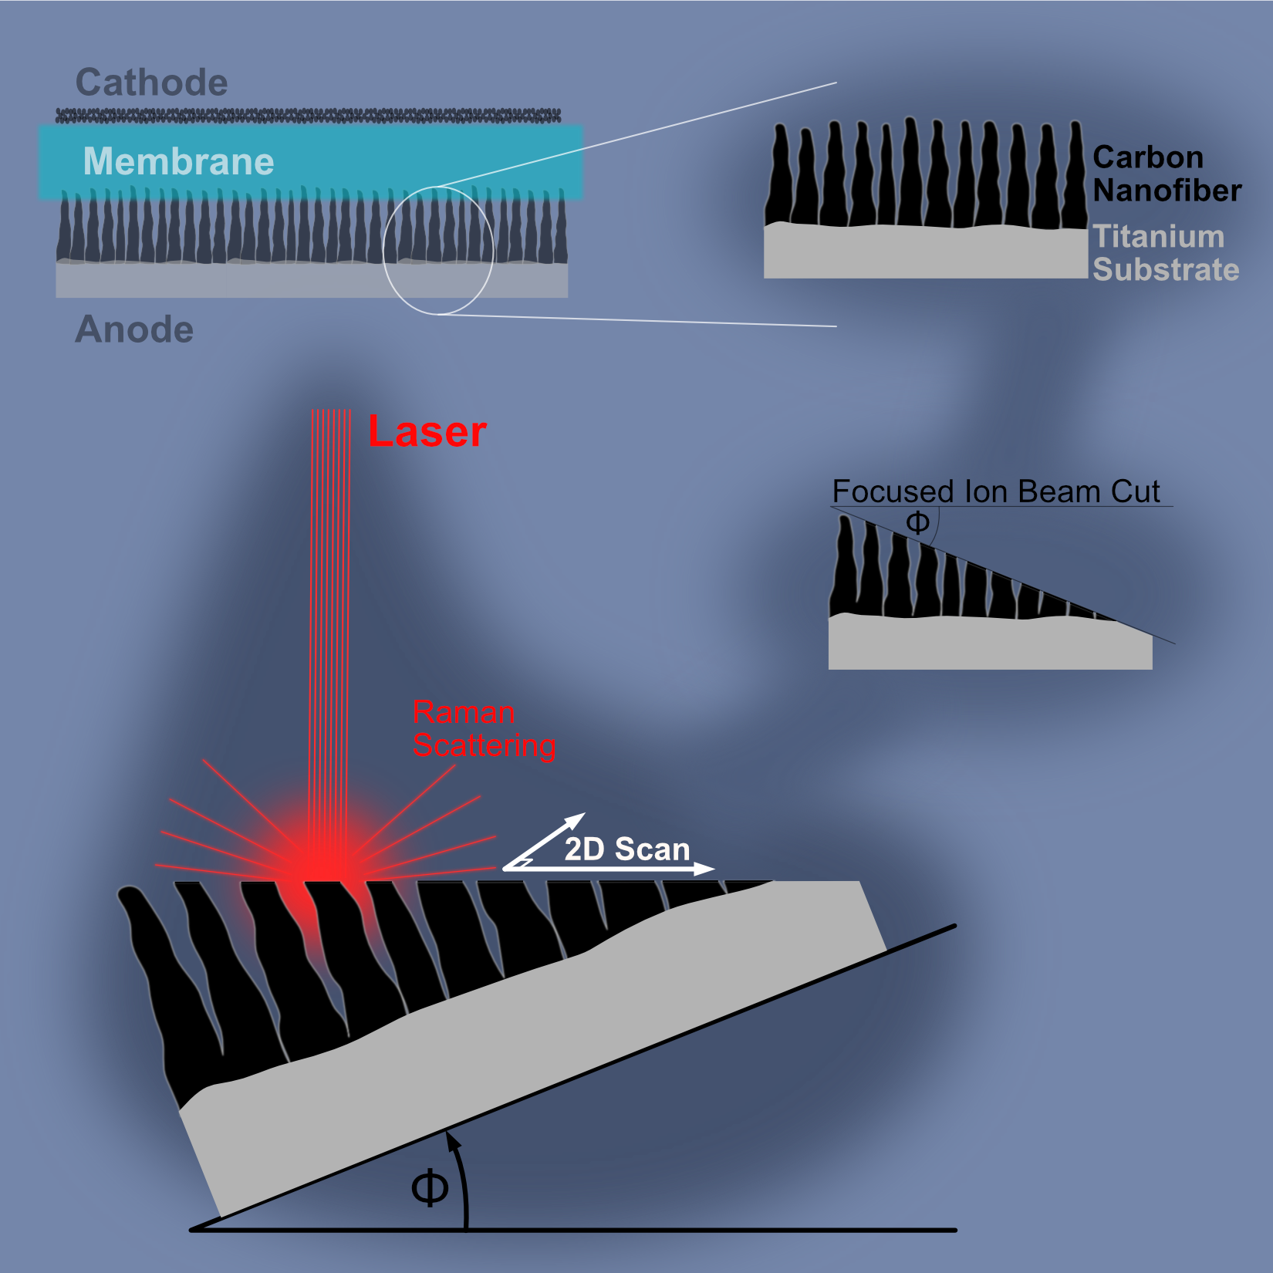

Figure 1: Schematic process for using a diagonal FIB section to enable better Raman mapping of a 3D electrode structure

